A Randomized, Multicenter, Double-Blind, Placebo Controlled Study of AC607 for the Treatment of Acute Kidney Injury in Cardiac Surgery Subjects
by COLUMBIA SURGERY on JULY 17, 2013

Yoshifumi Naka, MD, PhD
New-York Presbyterian/Columbia University is participating in a trial that is evaluating the use of human bone-marrow (Mesenchymal) derived stem cells (AC607), for the treatment of acute kidney injury (ACT-AKI). Naka, Yoshifumi, MD,PhD, Professor of Surgery and Director of both the Cardiac Transplantation Program and the Mechanical Circulatory Support Program is the principle investigator for the study sponsored by AlloCure, Inc (Burlington, MA).
What is the ACT-AKI clinical trial?
ACT-AKI is a randomized, double-blind, placebo-controlled, multicenter clinical trial evaluating the safety and efficacy of AC607 in cardiac surgery subjects who have laboratory evidence of post-operative acute kidney injury (AKI). AlloCure will enroll approximately 200 cardiac surgery subjects at leading tertiary care centers in the United States.
What are the effects of AKI?
AKI is a relatively common condition and is often associated with serious consequences. Recent epidemiologic assessments indicate that approximately 5 to 7% of all hospitalized patients may develop some degree of AKI. Moreover, when AKI occurs, the complications are potentially catastrophic both from patient and health-economic perspectives. AKI is associated with significantly increased in-hospital morbidity, mortality, and associated costs. While there have been a number of strategies evaluated for the treatment of AKI, no effective therapies are available beyond supportive measures including dialysis. AlloCure’s innovative cell therapy, AC607, offers the potential for improving outcomes in patients afflicted with this serious condition.
How is AC607 manufactured?
The human mesenchymal stem cells (MSC) used to formulate AC607 are derived and expanded from bone marrow obtained from healthy adult donors using a proprietary and mature state-of-the-art manufacturing process. These cells possess unique characteristics that make them ideal as a potential therapeutic including:
    - Immune privileged – avoids detection by the patient’s immune system
    - No donor matching – administered as an off-the-shelf product, obviating the need for blood or tissue typing
    - Genetically stable – not transformed or induced
What are the potential benefits of AC607 in treating AKI?
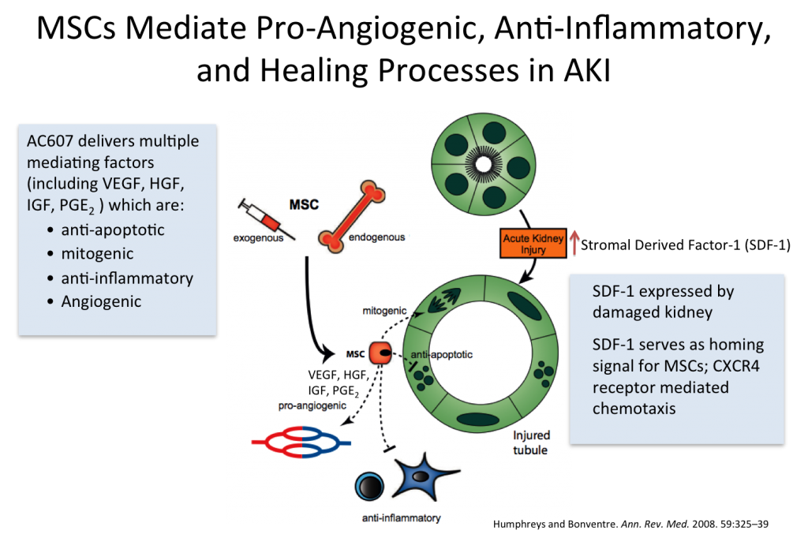
AlloCure has conducted extensive non-clinical studies demonstrating that the administration of allogeneic MSC prior to or after the development of AKI effectively enhances kidney repair and improves survival. These studies demonstrated that following AKI, the damaged kidney expresses increased levels of stromal-cell derived factor 1 (SDF-1). SDF-1 acts as a homing signal for MSC, bringing them to the site of injury to carry out their function. After reaching the injured kidney, MSC mediate anti-inflammatory and organ repair processes via the secretion of beneficial paracrine (cell to cell communication) factors, including vascular endothelial growth factor (VEGF), hepatocyte growth factor (HGF), insulin-like growth factor 1 (IGF-1) and others, which instruct the local damaged kidney cells to divide and survive rather than undergo apoptosis (cell death) and subsequent fibrosis. Notably, MSC are in residence in the injured kidney for only a short period of time and do not differentiate and re-populate the injured organ. The paracrine mediators produced by the stem cells act to preserve and restore kidney function following AKI via several mechanisms, including:
    - Anti-apoptotic (preventing existing cells from dying)
    - Mitogenic (promoting cellular reproduction)
    - Anti-inflammatory
    - Angiogenic (promoting vascularization of the tissue)
Due to these unique qualities, AC607 represents a promising approach for the treatment of AKI.
“The occurrence of AKI in patients undergoing cardiac surgery often has critical and costly consequences, yet we are still lacking approved remedies other than supportive care,” according to Dr. Naka. “AC607 has the potential to become that remedy, and the ACT-AKI Trial is moving this field in the right direction.”

